Virus Spread Agent-Based Model
  - CSC1111 - Building Complex Computational Models
Lee Hickey - 21407166
Emma Reen - [Student Number]
April 2026

1. Introduction

1.1 Purpose
This project implements an Agent-Based Model (ABM) simulating how a virus spreads through a population. The model uses the SIR framework where individuals are either Susceptible, meaning they can catch the virus, Infected, they have the virus, or Recovered, they have had the virus and are now immune.
The simulation aims to:
- Show how diseases spread through proximity between individuals
- Demonstrate the effect of various parameters like infection rate, population, recovery rate and social distancing
- Visualise epidemic dynamics with real-time graphs
- Allow experimentation with a wide range of different scenarios

1.2 Why Agent-Based Modelling?
ABMs simulate each individual separately; this captures important real-world features like spatial clustering and randomness in transmission. Each agent makes independent decisions based on very simple rules, but complex patterns emerge from their interactions.

2. Model Description

2.1 Agents
Each agent represents a singular person and has:
- Position (x, y) - location in 2D space
- State - Susceptible (S), Infected (I), Recovered (R), or Dead (D)
- Velocity - direction of movement
- Timer - tracks how long they have been infected

2.2 Rules
Movement:
Agents move randomly through the space. They bounce off walls and change direction slightly each step. Social distancing reduces movement speed.
Infection:
When an infected agent comes within the infection radius of a susceptible agent, the susceptible agent may become infected based on the infection probability.
Recovery/Death:
After a set number of steps (recovery_time), infected agents either recover and therefore become immune or die (based on mortality_rate).

2.3 Why These Rules?
Rule | Real-World Basis
Random movement | Simulates daily activities and chance encounters when a virus is at large before restrictive health measures are taken into place.
Proximity infection | For this instance, we are implying this virus spreads airborne through proximity and no direct contact is required.
Probability of infection | Not every contact leads to infection
Recovery time | Represents the infectious period of the disease – it is possible to explore further with a probability of recovery time by immune system assumptions, as well as the probability of re-infection.

3. Parameters
The model can be configured with these parameters:
Parameter | Default | Description
population | 200 | Total number of agents
initial_infected | 5 | Number infected at start
infection_prob | 0.3 | Chance of infection on contact (0-1)
infection_radius | 0.03 | Distance required for transmission
recovery_time | 100 | Time steps until recovery
mortality_rate | 0.0 | Chance of death instead of recovery (0-1)
social_distancing | 0.0 | Reduces agent movement (0-1)

4. Implementation
Technology:
- Language: Python 3
- Libraries: NumPy, Matplotlib
- No external ABM frameworks used - built from scratch
Features:
- 2D graphical display showing agents colour-coded by state
- Real-time time-series graph
- Interactive buttons: Start/Stop, Reset
- Slider to adjust parameters during simulation
Code Structure:
- Agent class - stores position, state, and movement
- initialize() - creates the population
- update() - runs one simulation step
- Animation loop - updates display 20 times per second

5. Results

5.1 Scenario 1: Baseline
Parameters all set to default which we have researched to closely mirror COVID 19:

- population = 500
- initial_infected = 5
- infection_prob = 0.4
- infection_prob=0.3
- infection_radius= 0.01
- recovery_time = 100
- mortality_rate = 0.2
- social_distancing = 0
- movement_speed=0.01
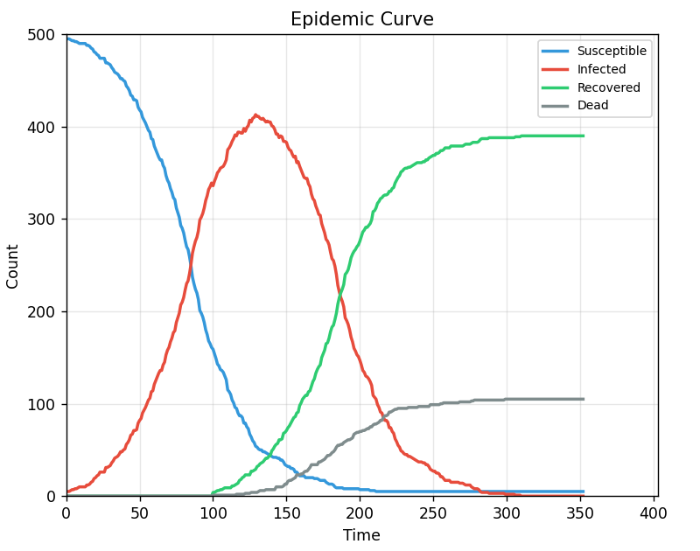

Observations:
- Classic SIR epidemic curve shape
- Infection spreads exponentially at first
- Peak infection around 180 agents (90% of population)
- Epidemic ends after ~250 time steps

5.2 Scenario 2: High Transmission
Parameters: infection_prob=0.7, infection_radius=0.05
[INSERT SCREENSHOT: scenario2_high_transmission.png]
Observations:
- Much faster spread - epidemic peaks earlier
- Nearly 100% of population infected
- Sharper peak, shorter duration

5.3 Scenario 3: Social Distancing
Parameters: social_distancing=0.7
[INSERT SCREENSHOT: scenario3_social_distancing.png]
Observations:
- "Flattening the curve" - peak reduced from 180 to ~60
- Epidemic spreads more slowly
- Some agents never get infected
- Demonstrates effectiveness of social distancing

5.4 Scenario 4: Mortality
Parameters: mortality_rate=0.1
[INSERT SCREENSHOT: scenario4_mortality.png]
Observations:
- 10% of infected agents die instead of recovering
- Dead agents shown in grey, accumulate over time
- Final death toll: ~20 agents

6. Outputs Tracked
The simulation records these metrics over time:
- Susceptible count - agents who have not been infected
- Infected count - currently infected agents
- Recovered count - agents who recovered and are now immune
- Dead count - agents who died from the infection
- Time step - current simulation time
These are displayed as a real-time graph showing the classic "epidemic curve" that health officials use to track disease outbreaks.

7. Discussion
Key Findings:
- Social distancing significantly reduces peak infections
- Higher infection probability leads to faster but shorter epidemics
- Spatial clustering creates hotspots of infection
- Random chance means each simulation run is slightly different
Limitations:
- Simplified 2D space does not represent real geography
- All agents behave identically (no age/health differences)
- No incubation period (agents are infectious immediately)
- No vaccination or quarantine mechanisms
Possible Extensions:
- Add quarantine for infected agents
- Include vaccination
- Different agent types (e.g., healthcare workers)
- Multiple virus variants

8. Conclusion
This Agent-Based Model successfully simulates virus spread dynamics in a spatial population. The model demonstrates key epidemic phenomena including exponential growth, peak infection, and the effectiveness of social distancing. The interactive visualisation allows users to experiment with parameters and observe their effects in real-time.

9. How to Run
Requirements:
pip install numpy matplotlib

Run the simulation:
python virus_sim.py

Controls:
- Start/Stop - begin or pause the simulation
- Reset - restart with initial conditions
- Slider - adjust infection probability in real-time

To change parameters:
Edit the values at the top of virus_sim.py and re-run or use the variable slides at hand in the GUI.

Code Repository:
[INSERT YOUR GITLAB LINK HERE]

10. References
1. Sayama, H. (2015). Introduction to the Modeling and Analysis of Complex Systems.
2. PyCX Project: https://github.com/hsayama/PyCX
3. Epstein, J. M. (2009). Modelling to contain pandemics. Nature, 460(7256).

